188 Cobra Squadron
Royal Canadian Air Cadets
LCol George Taylor Denison III Armoury
1 Yukon Lane, Trailer B
Toronto, ON M3K 0A1

1085-10 (Trg O)

11 September 2019

Distribution List

OPERATION ORDER
Fall Field Training Exercise

References: A. RCAC Proficiency Level One – Instructional Guides A-CR-CCP-801/PG-001
B. RCAC Proficiency Level Two – Instructional Guides A-CR-CCP-802/PG-001
C. RCAC Proficiency Level Three – Instructional Guides A-CR-CCP-803/PG-001
D. RCAC Proficiency Level Four – Instructional Guides A-CR-CCP-804/PG-001

SITUATION

- As outlined in the Proficiency Level 1-4 Qualification Standard and Plan (QSP), all cadets must participate in a mandatory field training exercise in order to fulfill their proficiency level requirements.

MISSION

- Cadets and Staff of 188 Cobra Squadron RC(Air)C shall participate in a field training exercise on the weekend of 04-06 October 2019 at Blackdown Cadet Training Centre.

EXECUTION

- General Outline: This operation will be completed in five (5) phases:

- Phase 1 - Administration

Grouping and Taskings: Capt La, Capt Vy.

  - Assign classes and instructors per Annex A;

  - Submit CSAR and Op Order NLT 11 September 2019;

  - Enter activity into FORTRESS;

  - Post activity information, sign up sheet and kit list on the squadron webpage (See Annex C);

  - Verify all enrollment paperwork is complete; and

  - Print nominal roll from FORTRESS.

- Phase 2 – Advance Party (AP)

Grouping and Taskings: Capt La, 2Lt Kontis, AP TBD

  - Pick up vehicle from Denison Armoury MSE Transport;

  - Pick up equipment from squadron supply (See Annex D);

  - Drive to Blackdown Cadet Training Centre (See Annex E);

  - Pick up equipment from Blackdown Stores (See Annex D); and

  - Set up training areas

- Phase 3 - Training

Grouping and Taskings: Capt La, Instructors

  - Issue kit;

  - Assign cadets to tents (based on gender);

  - Conduct training per Annex B.

- Phase 4 - Tear down

Grouping and Taskings: All personnel.

  - Ensure all equipment is accounted for;

  - Return equipment to Blackdown Stores;

  - Ensure garbage sweep is completed; and

  - Return equipment to squadron supply.

- Phase 5 - Post-exercise Administration

Grouping and Taskings: Capt La
  - Dismissal of cadets;

  - Debrief adult staff and staff cadets;

  - Distribute after-action report forms (See Annex F);

  - Collect completed after-action reports;

  - Complete attendance on FORTRESS; and

  - Submit any claims/expenses to NGTA Area Office.

- Coordinating Instructions:

- Schedule. See Annex B.

- Dress:

- CAF members shall wear issued CADPAT clothing IAW CF Dress regulations.

- Cadets, Civilian Volunteers and Civilian Instructors are permitted to wear olive green combats with their rank slip-ons. Appropriate civilian clothing may also be worn.

SERVICE SUPPORT

- Accommodations:

  - Level 1, 2 and 3 cadets shall be accommodated in soft wall shelters; and

  - Level 4 and 5 cadets shall be accommodated at H1 Bivouac Site Triangle.

  - In the event of inclement weather, all personnel shall relocate to soft wall shelters.

- Environmental:

  - All personnel shall ensure that they are mindful of the environment at all times.

  - Should any spills occur, an environmental kit will be on hand to aid in cleanup of the spill.

- Medical:

  - Minor injuries will be treated on site by a first aid certified personnel.

  - Serious injuries will be treated at Stevenson Memorial Hospital located at 200 Fletcher Crescent, Alliston, ON (See Annex G).

  - All personnel are required to have their health card on their person at all times.

- Rations:

  - Meals on Route have been requested on the CSAR for Advance Party lunch and dinner on 04 October 2019. Mess Hall has been requested for breakfast on 05 October 2019.

  - Meals Ready to Eat (MREs) will be provided for all personnel for lunch and dinner on 05 October 2019 and breakfast on 06 October 2019.

  - Mess Hall has been requested on the CSAR for lunch on 06 October 2019.

- Transportation:

  - All personnel shall arrive at and depart from Denison Armoury by their own means of transportation.

  - One (1) panel has been requested to transport training material and equipment to and from the training site. In addition, this vehicle will be used as an emergency vehicle.

  - Three (3) school busses have been requested to transport main body to and from training site.

COMMAND AND SIGNALS

- Chain of Command:

  - OIC: Maj Shael Reiken hsreiken@gmail.com 416-276-3663;

  - OPI: Capt Brenda La brenda.la@cadets.gc.ca, 416-825-7877; and

  - First Aid: OCdt Jessie Nguyen 416-509-8163.

//signed//

Brenda La
Captain
Training Officer
188 Air RC(Air)CS

Annexes:

Annex A – Classes
Annex B – Schedule
Annex C – Kit list
Annex D – Equipment/Supply List
Annex E – Route to Blackdown Cadet Training Centre
Annex F – After-Action Report Form
Annex G – Route to Stevenson Memorial Hospital

Distribution List

Action

CO
AdmO
SupO
SWO

Information

J3 Zone TrgO

Annex A – Classes

Level 1
PO/EO | Class | Time | Instructor
M190.03 | Observe Site Policies and Procedures | 60 min | TBD
M190.04 | Discuss Survival Psychology | 60 min | TBD
M190.05 | Identify Types of Shelters | 30 min | TBD
M190.07 | Erect, Tear Down and Pack Tents | 90 min | TBD
C190.02 | Tie Knots and Lashings | 60 min | TBD
C190.03 | Construct a Hootchie-Style Shelter | 90 min | TBD
C190.04 | Collect Drinking Water in the Field | 60 min | TBD
C190.05 | Identify Environmental Injuries | 30 min | TBD
C190.06 | Respect the Environment in the Field | 30 min | TBD
PT | Physical Training | 30 min | TBD
Level 2
PO/EO | Class | Time
M290.02 | Construct a Lean-to-style Shelter | 90 min | TBD
M290.03 | Construct a Simple Snare | 60 min | TBD
M290.05 | Identify Hiking Techniques | 60 min | TBD
M290.06 | Operate a Hand-held Radio | 30 min | TBD
C290.02 | Discuss Skinning and Cooking a Small Animal | 30 min | TBD
C290.04 | Collect Drinking Water Using a Solar Still | 60 min | TBD
C290.05 | Participate in a Hike | 180 min | TBD
PT | Physical Training | 30 min | TBD
Level 3
PO/EO | Class | Time
M390.01 | Identify Parts of the Compass | 30 min | TBD
M390.02 | Identify Marginal Information and Conventional Signs | 60 min | TBD
M390.03 | Determine Grid References (GRs) | 60 min | TBD
M390.04 | Determine Distance on a Map and on the Ground | 90 min | TBD
M390.05 | Determine Bearings on a Map and on the Ground | 60 min | TBD
390 PC |  | 120 min | TBD
C390.11 | Construct Camp Crafts | 120 min | TBD
Level 4
PO/EO | Class | Time | Instructor
M490.02 | Operate a Stove and a Lantern | 90 min | TBD
C490.02 | Improvise Tools for Use in a Survival Situation | 60 min | TBD
C490.03 | Move a Casualty to Shelter | 90 min | TBD
C490.04 | Practice Safe Toolcraft | 90 min | TBD
C490.06 | Erect, Tear Down and Pack Tents | 120 min | TBD
C490.07 | Construct a Hootchie or Lean-to-Style Shelter | 90 min | TBD

05 Oct 19 | Level 1 | Level 2 | Level 3 | Level 4
Period 1 | M190.03 | M290.03 | M390.01 | M490.02
Period 2 | M190.03 | M290.03 | M390.02 | M490.02
Period 3 | M190.05 | M290.06 | M390.02 | M490.02
LUNCH
Period 4 | M190.07 | M290.05 | M390.03 | C490.07
Period 5
Period 6 | M190.07 | M290.02 | M390.04 | C490.07
Period 7 | M190.04 | M290.02 | M390.04 | C490.06
Period 8
Period 9 | C190.02 | C290.05 | M390.05 | C490.06
Period 10
Period 11 | C190.03 | C290.05 | C390.011 | C490.02
Period 12
Period 13 | C190.03 | C290.05 | C390.011 | C490.03  (Ext 30 mins)
Period 14 | C190.05 | C290.05 | C390.011 | C490.03  (Ext 30 mins)
06 Oct 19
Period 15 | PT | PT | BREAKFAST
 | BREAKFAST |  | 390 PC | C490.04
Period 16 | C190.04 | C290.04 | 390 PC | C490.04
Period 17
Period 18 | C190.06 | C290.02 | 390 PC | N/A
LUNCH

Annex B – Schedule

04 October 2019

1130 Advance Party (AP) arrives at Denison Armoury
AP pickup panel van
1200 – 1230 AP load squadron supplies and equipment
1230 – 1430 AP depart for Blackdown CTC
AP LUNCH
1430 AP arrives at Blackdown CTC
1430 – 1530 AP pickup equipment from Blackdown Stores
1530 – 1700 AP set up training Site
1700 – 1800 AP DINNER

05 October 2019

0730 Main Body (MB) arrives at Denison Armoury
MB Attendance
MB Kit Inspection
MB Load Bus
0800 MB departs for Blackdown CTC
0930 – 1025 MG arrives at Blackdown CTC
Briefing
Tent Assignment
Syndicate Assignment
Issue sleeping bag and liner
1030 – 1100 Training Period #1
1105 – 1135 Training Period #2
1140 – 1210 Training Period #3
1210 – 1310 LUNCH
1315 – 1345 Training Period #4
1350 – 1420 Training Period #5
1425 – 1455 Training Period #6
1500 – 1530 Training Period #7
1535 – 1405 Training Period #8
1410 – 1440 Training Period #9
1445 – 1515 Training Period #10
1520 – 1550 Training Period #11
1555 – 1625 Training Period #12
1630 – 1700 Training Period #13
1705 – 1735 Training Period #14
1740 – 1840 DINNER
1845 – 2000 Night Game/Hodge Podge
2000 - 2200 Cookies/Hot Chocolate/Washup
2200 Lights Out
Fire Piquet Begins
2230 O Group

06 October 2019

0700 Reveille
0700 – 0730 Ablution
0735 – 0805 Training Period #15
0810 – 0910 BREAKFAST
0915 – 0945 Training Period #16
0950 – 1020 Training Period #17
1025 – 1055 Training Period #18
1100 – 1200 LUNCH
1200 – 1300 Tear-Down
1300 Load Bus
Depart Blackdown CTC
1430 Arrive at Denison Armoury
Post-exercise administration
1500 Dismissal
Annex C – Kit List

Cadets shall bring:
- Health Card
- sweatshirt
- outdoor shoes
- warm jacket
- shirt (3)
- pants (2)
- socks (4)
- hat
- undergarments (3)
- toothbrush
- toothpaste
- hairbrush
- deodorant
- pen and paper
- prescription medication/glasses/contacts
- soap
- towel
- face cloth
- rain gear (poncho/jacket/etc)
- water bottle
- flashlight
- sunscreen

Optional:
- combat clothing (only olive green pattern)

DO NOT BRING:
- Electronic devices such as IPODS, MP3 Players, stereos, game systems, etc.
- Jewellery
- Knives, drugs, alcohol
- Large sums of money
Annex D – Equipment/Supply List

Squadron Supply
 | Item | Quantity Requested | Quantity Issued
1. | First Aid Kit | 2
2. | Cookies | 25 x 350g packs
3. | Hot chocolate | 3 canisters
4. | Juice Packs | 200 boxes
5. | Bottled water | 100 bottles
6. | Disposable ponchos | 100

J4 Warehouse
See attached Warehouse request spreadsheet.

Annex E – Route to Blackdown Cadet Training Centre

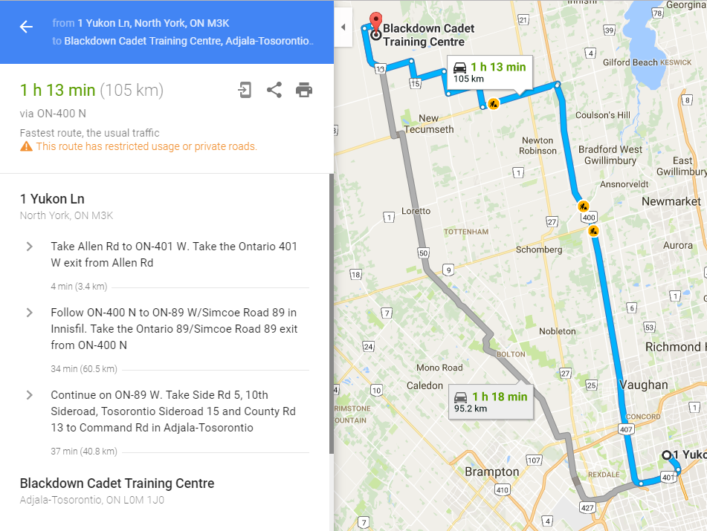

Annex F – After-Action Report Form

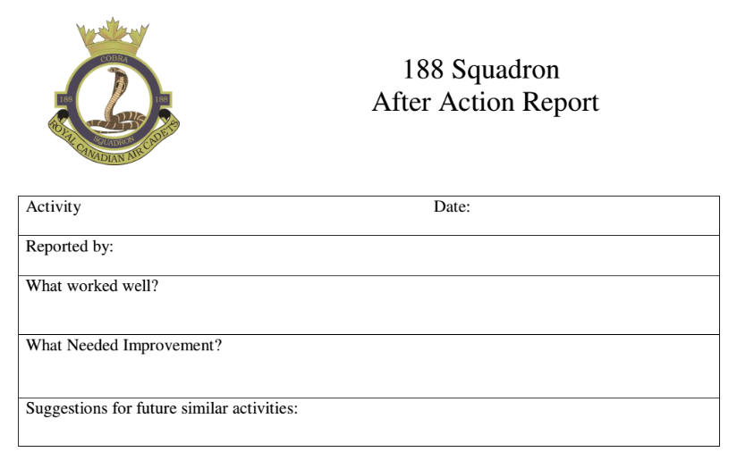

Annex G – Route to Stevenson Memorial Hospital

